**Assignment Cover Sheet**

|  |  |  |
| --- | --- | --- |
| **Qualification** | | **Module Number and Title** |
| Higher Diploma in computing and software engineering | | **CSE 5009**/ Web Application Development |
| **Student Name & No.** | | **Assessor** |
| Bawantha Dissanayake  KD/HDCSE/CMU/69/37 | | Divaskar Rajkumar |
| **Hand out date** | | **Submission Date** |
|  | |  |
| **Assessment type**  Writ1 | **Duration/Length of**  **Assessment Type**  **3000 words** | **Weighting of Assessment**  100% |

|  |  |
| --- | --- |
| **Learner declaration** | |
| I, … Bawantha Dissanayake KD/HDCSE/CMU/69/37  …, certify that the work submitted for this assignment is my own and research sources are fully acknowledged. | |
| |  |  |  |  | | --- | --- | --- | --- | | **Marks Awarded** | | | | | First assessor | |  | | | IV marks | |  | | | Agreed grade | |  | | | Signature of the assessor |  | Date |  | |

**Feedback Form**

**International College of Business & Technology**

**Module:** Web Application Development

**Student:** Bawantha Dissanayake

**Assessor: Divaskar Rajkumar**

**Assignment: FitzoneFitness Website**

**Strong features of your work:**

**Areas for improvement:**

**Marks Awarded:**

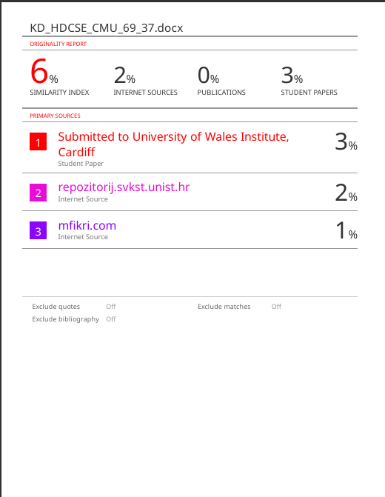

# Introduction

The development of a modern, user-friendly website requires thorough planning, design, implementation, and testing to ensure functionality and ease of use. This project, a web application for Fit Zone Fitness Center, was created to provide an engaging platform where users can explore classes, register for appointments, and manage their membership details. With the rise of digital fitness solutions, this website aims to bridge the gap between fitness enthusiasts and gym management by offering convenient access to information and interactive features. The development process involved evaluating similar websites, designing clear use case and class diagrams, creating a detailed user interface, building a robust backend, and conducting thorough testing to ensure responsiveness, compatibility, and user satisfaction.

# Acknowledgement

I would like to express my heartfelt gratitude to my campus faculty and mentors who provided valuable insights, guidance, and encouragement throughout the development of this project. Special thanks to my peers for their collaborative feedback, which played a crucial role in refining the website's functionalities

Table of Contents

Introduction 3

Acknowledgement 4

Task 01 5

a) Comparison of similar systems 5

Color Combination 10

**Summary** 14

b) User Interface design and sitemap of the planned web application 15

Site Map 15

Wireframe Diagrams 15

**Task 02** 19

Front-End Development 19

Overview of Front-End Development 19

Technologies Used 19

Front-end 20

Task 03 24

Back-end development 24

Overview of Backend Development 24

Database Structure 25

Database connection 25

Payment Process 26

Using Session 26

Conclusion of Back-end Development 26

Task 04 27

Testing the FitZone Web application 27

Testing Overview 27

Testing and evaluation of the system 27

Scope: 27

Test Cases 28

Feedback Evaluation and Future Recommendations 39

Feedback Evaluation 39

Future Recommendations 39

Summary 40

References 41

# Task 01

Planning and designing the web application.

## Comparison of similar systems

The following restaurants were observed to get an idea on how to design an attractive web store for the **FitZone Fitness**. The observations were done mainly under few categories

1. Power world
2. Global fitness
3. Lifetime fitness
4. Karve
5. Power world

Home Page

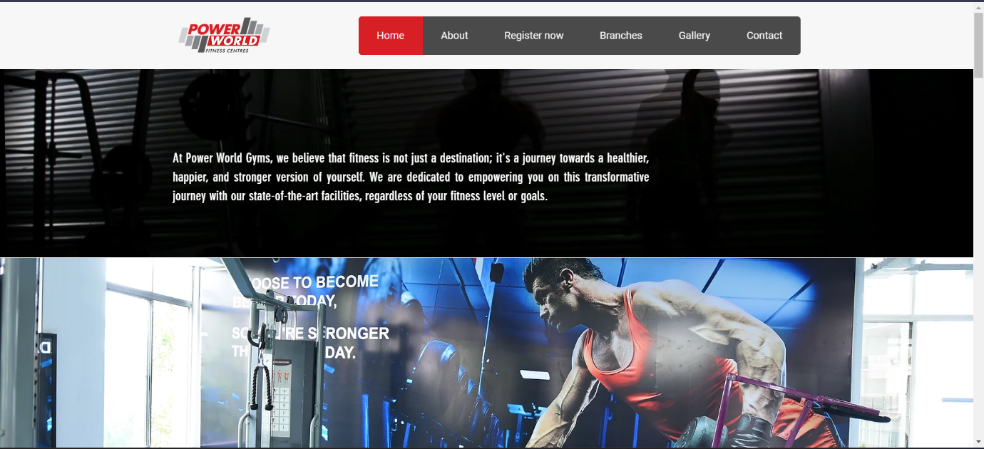

The layouts of Power World Gyms official website are clean and modern with an appealing motivational and fitness oriented design. Top, there are tabs that include Home, About, Register Now, Branches, Gallery, and Contact, besides the Power World logo. The navigation area is placed below and it is accompanied by a motivational quote that points at the gym’s main idea, which is that fitness makes one powerful, happy, and healthy. This message having pictures of exercise equipment with the background black makes the message to have a strong and concentrated feel. The group motivation message in the gym is also demonstrated by the changing background image of a muscular man exercising.

Navigation Bar



The website of the Power World Fitness Centres has a simple navigation bar at the top of the page. It has the logo on the left side wearing a red and gray color writing the name of the brand in a large, bold font. The items listed on the navigation menu to the right of the logo are Home, About, Register now, Branches, Gallery, and Contact. The ‘Home’ tab has a red background and other tabs have a dark grey background so as to help differentiate between the active page. The buttons are round shaped making the interface to look sleek and professional, the use of the colors namely, red, gray, white makes the interface look professional. (powerworldgyms, 2024)

1. Global fitness

Home Page

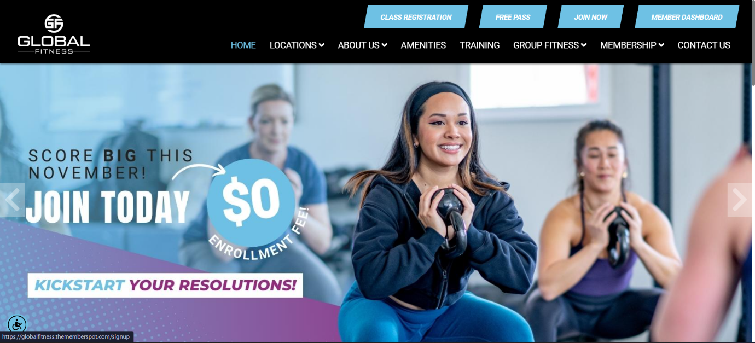

The primary page of the Global Fitness website comes with friendly focus on engaging the user; it comes with a warm feel to it. Areas such as Locations, Amenities, Training, and Membership options are handy at the top due to a powerful logo and navigation bar. Also, there is a highly-visible ‘top navigation’ bar with ‘Class Registration,’ ‘Free Pass,’ ‘Join Now,’ and ‘Member Dashboard’ buttons to help users act fast.

Relatively happy and warm disposition is adopted by utilizing a banner graphic with people exercising joyfully. It is sign up that is $0 to join through the layered text which is big, bold and colored to ensure visitors notice this invitation. Friendly and stimulating, the design aims to attract everybody who would like to start exercising without pressure or prejudice.

**Navigation Bar**



The Global Fitness is the name of the website, and the navigation bar of this site is well organized, having a modern look with a black background that makes it look even better. An effective element of a visual brand recognition is the logo on the left with the use of white stylized characters ‘G’ and ‘F’. In order to make the design clean and bold, the main navigation links include “Home,” “Locations”, “About Us”, “Facilities”, “Training”, “Group Fitness”, “Membership”, “Contact Us” all in white-colored capital letters. Some of the menu items have small arrows next to them, meaning there are more options under some of such sections.

The prominent blue rectangular buttons such as “Class Registration,” “Free Pass,” “Join Now,” and “Member Dashboard” located above the main menu makes work easier. Such buttons are highlighted on the black background and their blue color easily draws (globalfitnesscenter, 2024; globalfitnesscenter, 2024)

1. Lifetime fitness

Home Page

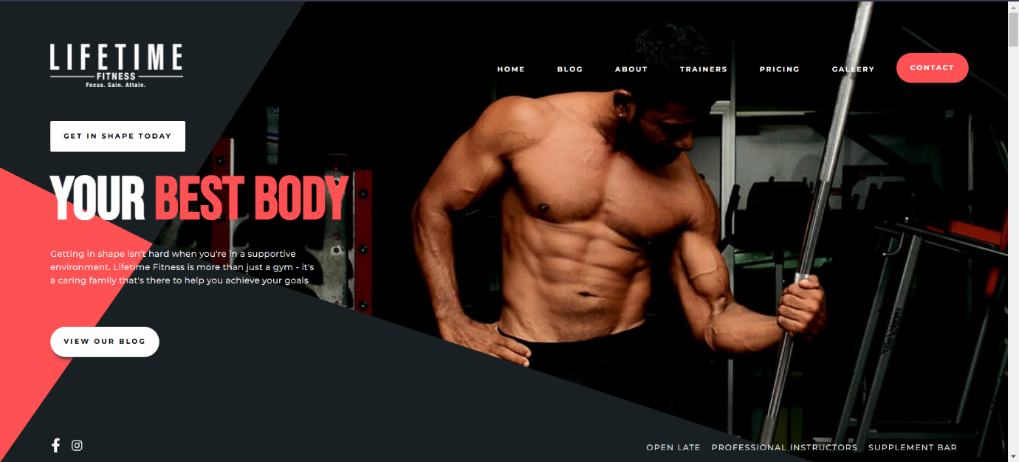

The Lifetime Fitness website homepage is designed to be bold and motivational, focusing on making an impactful first impression. The layout uses a dark background with striking red and white accents, giving it a modern and powerful look.

The big, bold typography of the "Your Best Body" banner immediately draws attention, emphasizing the gym's commitment to helping customers achieve their fitness goals.

A high-quality image of a muscular man draws attention to the strength and commitment of the brand. The page includes prominent buttons like "Get in Style Today" and "View Our Blog" for quick access, making it easy for users to connect.

The minimal navigation at the top includes links to sections like Blog, About, Coaches, Pricing, and Contact, along with a red-highlighted "Contact" button for quick inquiries. The overall design is intense yet inviting, for fitness enthusiasts looking for a supportive environment to transform their bodies.

Navigation Bar



The black background and bold, stylish style of the "Lifetime Fitness" website navigation bar create a dramatic effect that highlights the brand's high-end appeal.

Motto "Focus. Get. Achieve." Underscoring the brand's commitment to fitness goals, the left hand is displayed beneath the logo's sleek, contemporary lettering.

The navigation menu, located to the right of the logo, has a simple and minimal look thanks to links like "Home," "Blog," "About," "Coaches," "Pricing" and "Gallery."

White capital letter. The "Contact" button is easily recognizable by its bright red circular appearance, which immediately attracts users' attention and makes it simple to find the contact option. Contrast of red button, white writing and dark background to create (lifetimefitness, 2024)

1. Karve

Home Page

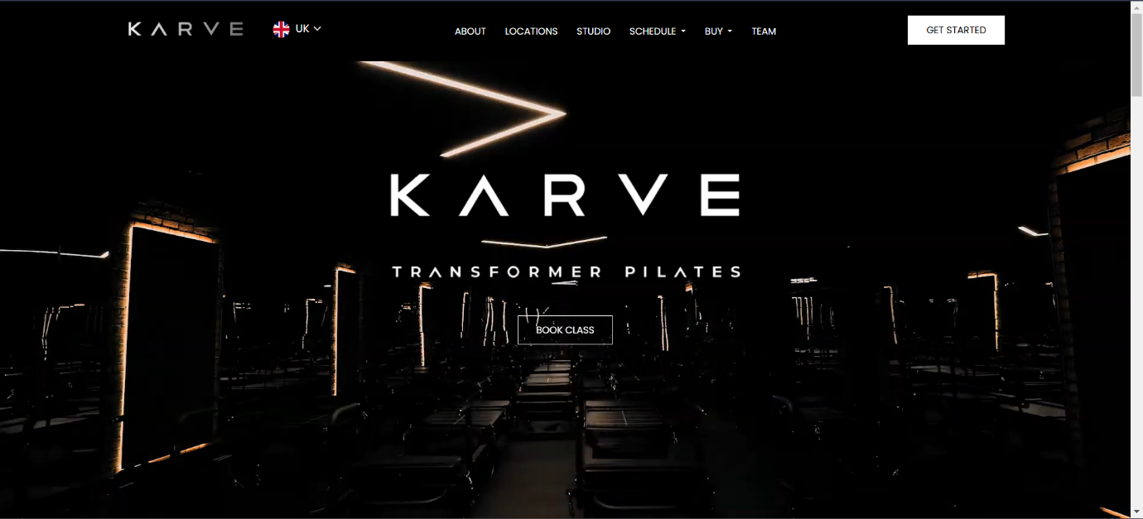

KARVE Transformer Pilates Website Smooth, modern and minimal homepage design website. Subdued lighting and dark color rendering that highlights the equipment in the background creates a lush and attractive environment. The logo is prominently positioned in the medium with a crisp, contemporary font that emphasizes a strong brand identity.The key call to action, "Book Class," is prominently displayed beneath the logo to promote immediate interaction.

With only a few options like "About," "Locations," and "Studio," the top navigation is simple and looks neat.This page intrigues a sophisticated audience looking for a high-end Pilates experience due to its unique and professional atmosphere created through the use of negative space and subtle lighting.

**Navigation Bar**



The bar at the top of this web is well designed, it has no clutter and is easily distinguishable in black color with white writings and icons. On the left there is a brand logo “KARVE,” below it on the badge there is a flag …selected country (as an example UK) if the site has different regional versions. The major menu items About, Locations, Studio, Schedule, Shop and Team are aligned centrally with the same equal distance between them which helps the visitor to find any part of the website with ease. To the right, there is the “GET STARTED” button underlined with the white box, which stares at getting attention as the call-to-action. This design is clear cut and one does not have to really think about where to click next about the website being used. (https://karve.club/, 2024)

# Color Combination

Power world



#1a1a1a: Gray



#fa4032: **Bright red**



White: #FFFFFF

Global Fitness



Light blue: #add8e6



Black: #000000



White: #FFFFFF



Purple: #d420f0

Lifetime fitness



Black: #000000



#1a1a1a: Gray



#fa4032: **Bright red**



White: #FFFFFF

Karve



Black: #000000



White: #FFFFFF

### **Summary**

|  |  |  |  |  |
| --- | --- | --- | --- | --- |
|  | Power world | Global Fitness | Lifetime fitness | Karve |
| Home Page | Poor | Better | Better | Better |
| Navigation Bar | Average | Good | Better | Better |

|  |  |  |  |  |
| --- | --- | --- | --- | --- |
| Overall Color Combination | Good | Better | Better | Better |
| Menu | Average | Average | Better | Better |
| About Us | Average | Good | Average | Better |

## User Interface design and sitemap of the planned web application

### Site Map

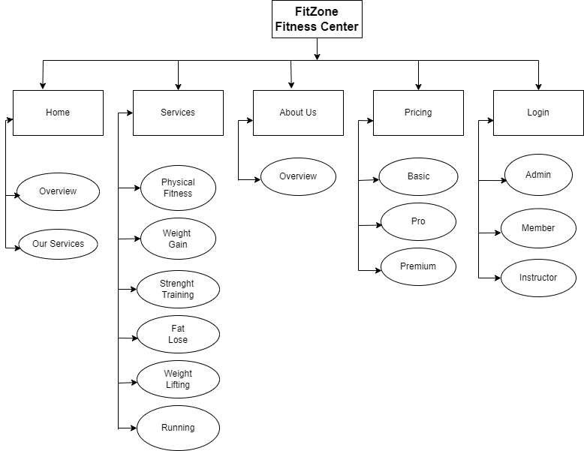

## Wireframe Diagrams

Home



Services



About Us



Pricing



Review



Login



Register

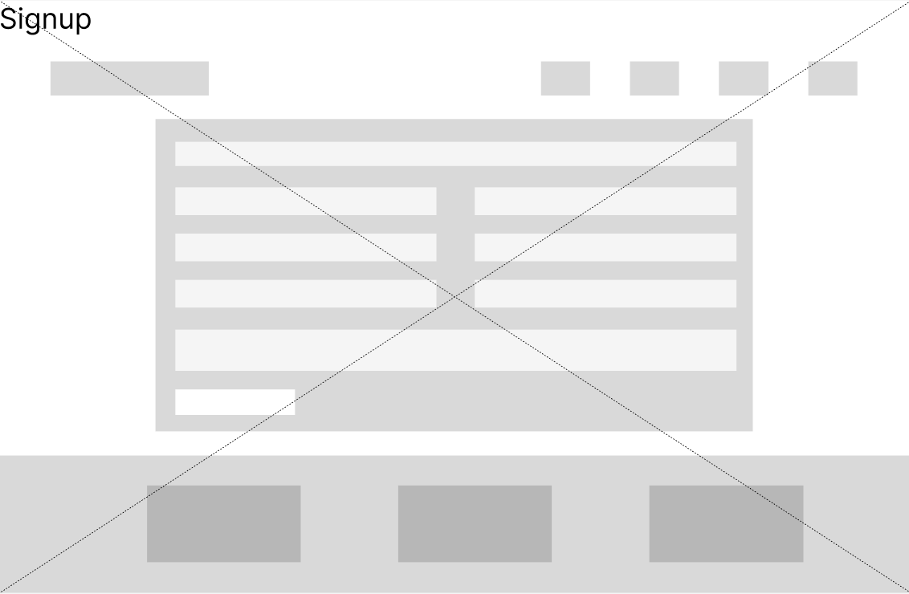

# **Task 02**

## Front-End Development

### Overview of Front-End Development

As the front-end of the Fit Zone Fitness Center application, the focus was to create as comfortable, beautiful, useful, and easy-to-use as possible. There are three basic user types of the program and each of them has corresponding scope and opportunities: the members, the instructor, and the administrators. Considering the fact that it was pertinent for users to have an easy time navigating and having an interaction with the content, every aspect was developed with usability, responsivity and accessibility. I built this site with a light green and black mixture as my theme.

### Technologies Used

* HTML: Application for defining components and layout of content web areas.
* CSS: Refers to non-content elements like typeface, color, design, and motion operational to create an amazing interface design.
* JavaScript: Improved interactivity of the program by adding functions such as the drop down menus, control bar, and real-time form.
* Bootstrap: To ensure that design is appropriately responsive across devices while simultaneously maintaining compatibility, Bootstrap provided a means for a responsive grid system, components, and utility.
* Font Awesome: Incorporated in iconography for the enhancement of user interface and attractiveness.

### Front-end

Home

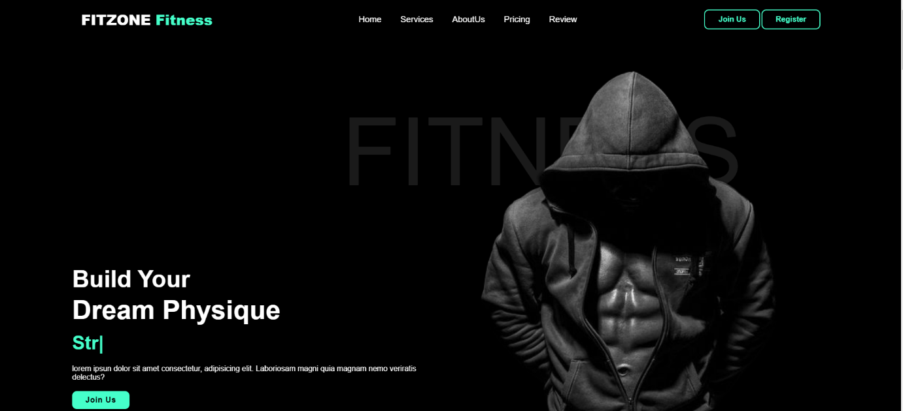

About Us

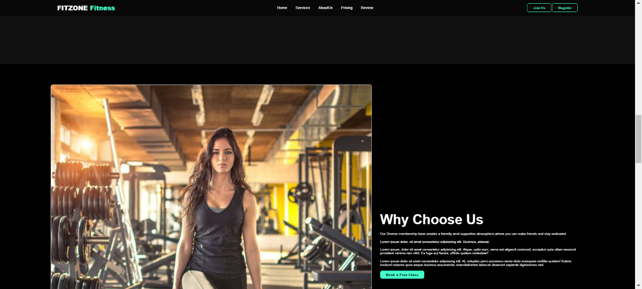

Classes

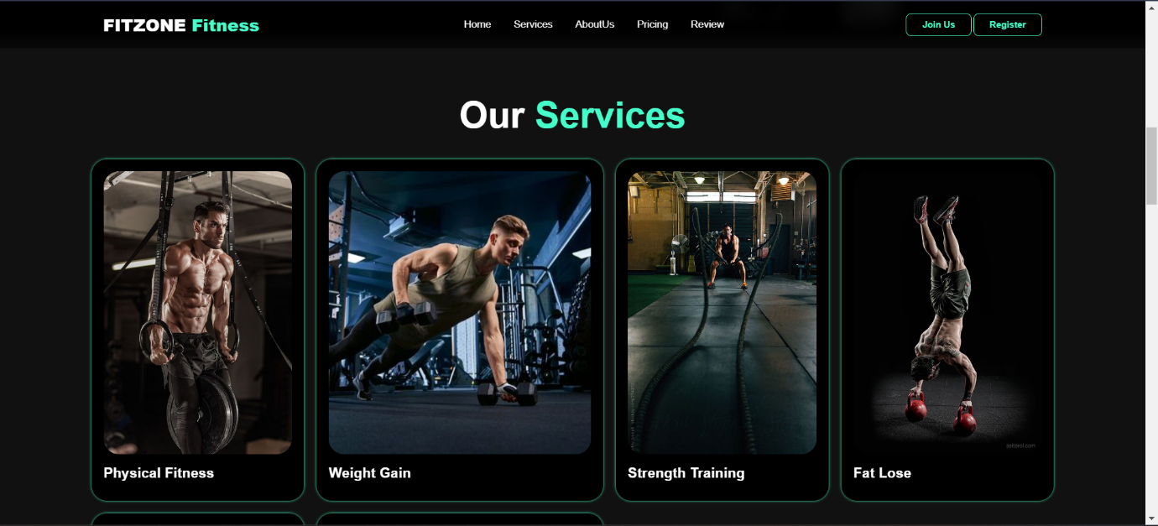

Membership

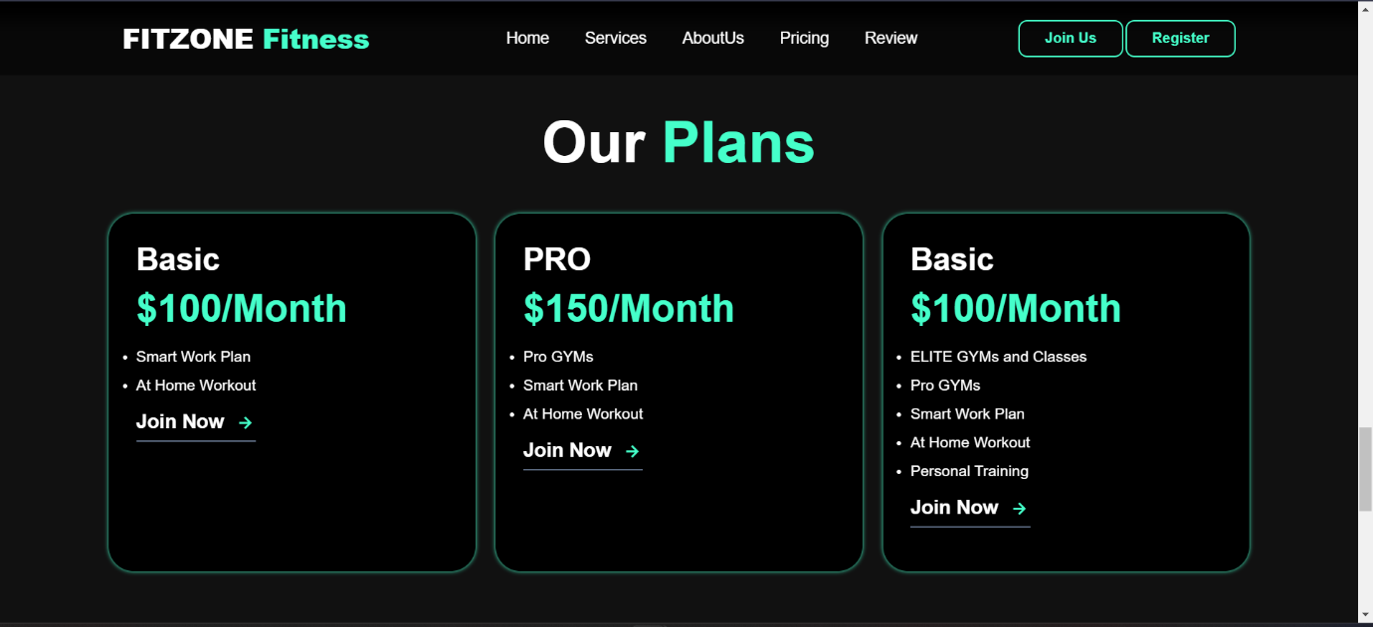

Review

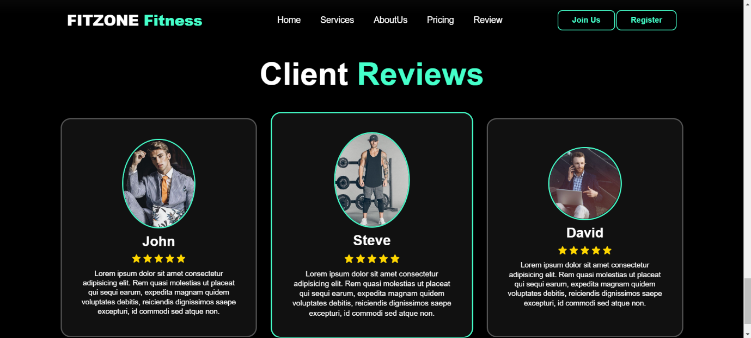

Register

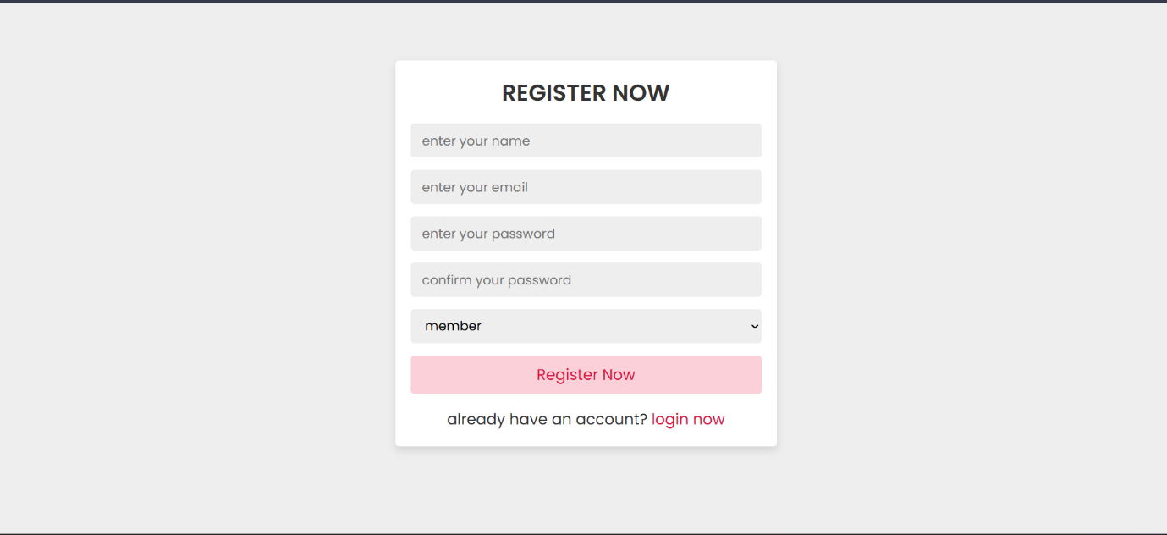

Login

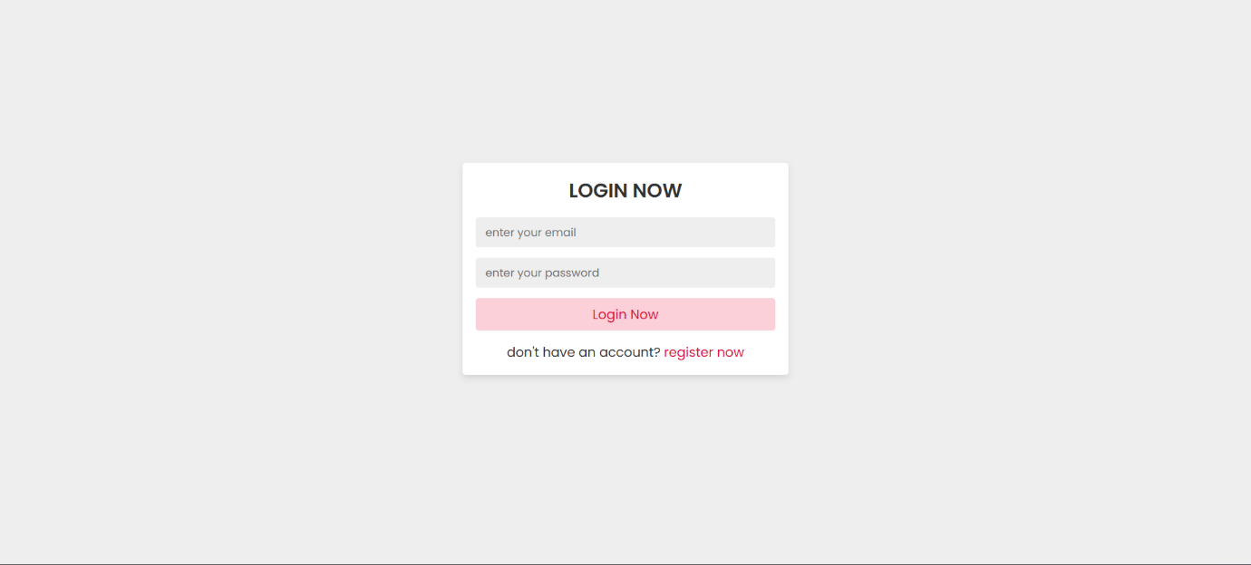

Admin Dashboard

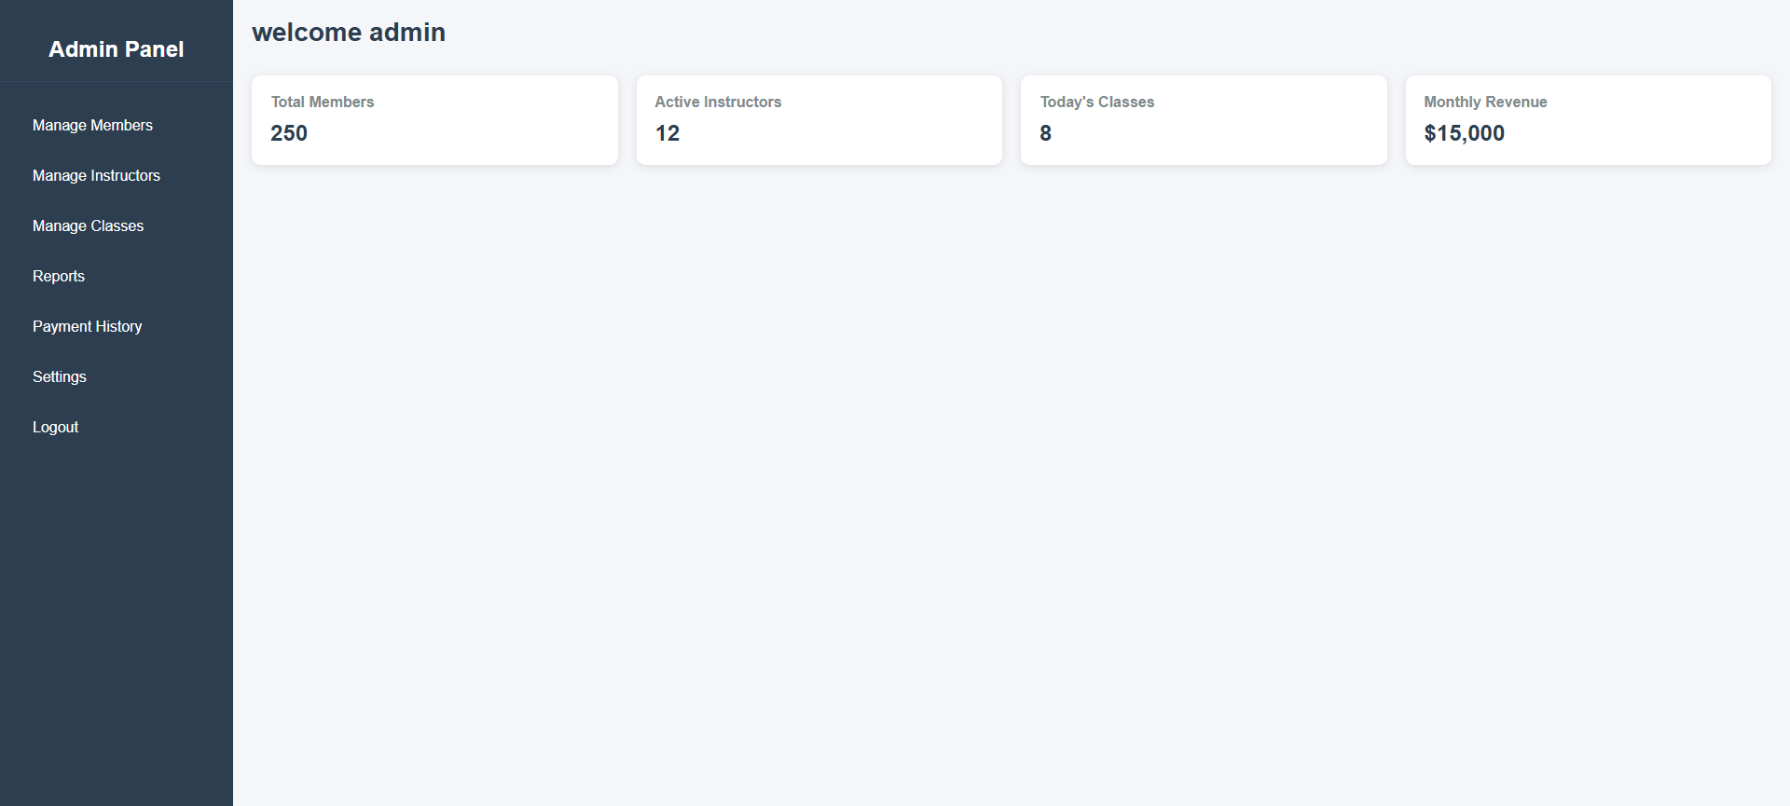

Payments

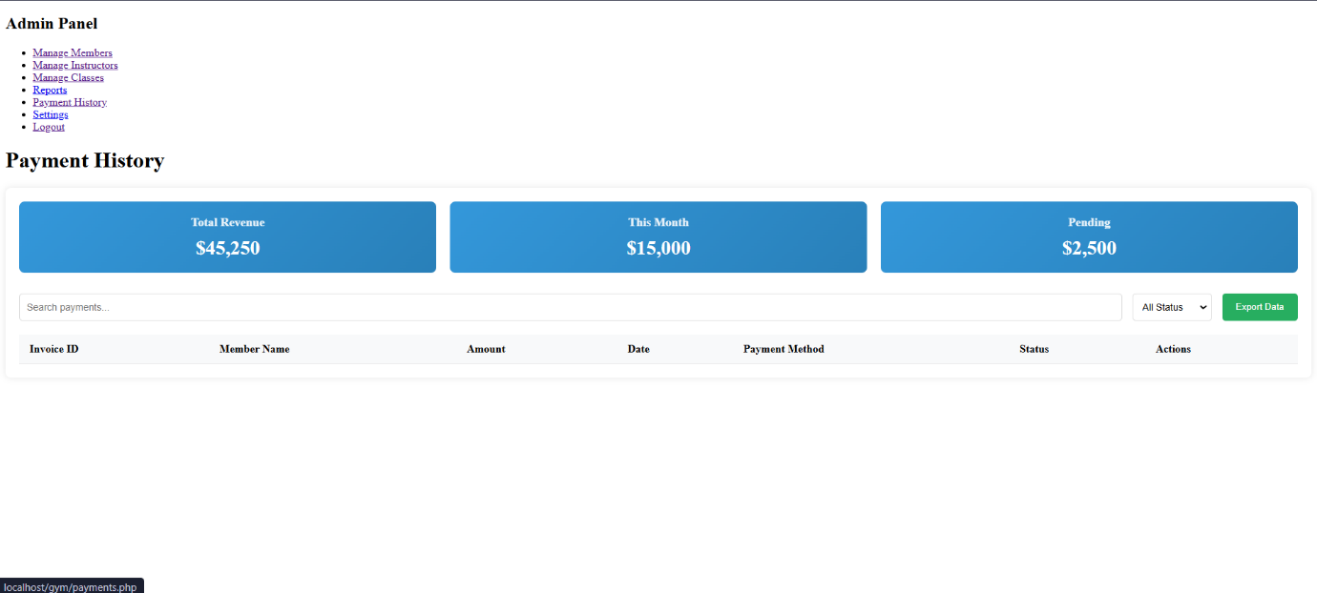

# Task 03

## Back-end development

## 

### Overview of Backend Development

The FitZone Fitness Center application’s backend was developed focusing the ideas of safety, efficiency and reliability of the user-system relations. Some of the key features include users’ management, classes scheduling, membership processing and administration. As for the backend, PHP and MySQL technologies were pick and used and proved to be highly efficient, promising secure data processing and stable work without losing stability, reliability or performance.

#### Technologies Used

* Applications to SOMA database interfaces, executing sessions, and form processing.
* To store information about users, classes, memberships, bookings and inquiries, the relational database management system, MySQL, is used. Organization of MySQL provided efficiency in processing, retrieving or storage of data.
* AJAX: Let the client and server interact asynchronously which enable efficient communication without using the page reload option to make the user interface more friendly and faster.
* JSON: Works to transmit data between the client and server especially when in AJAX activities to load more dynamic data.

# Database Structure

## Database connection

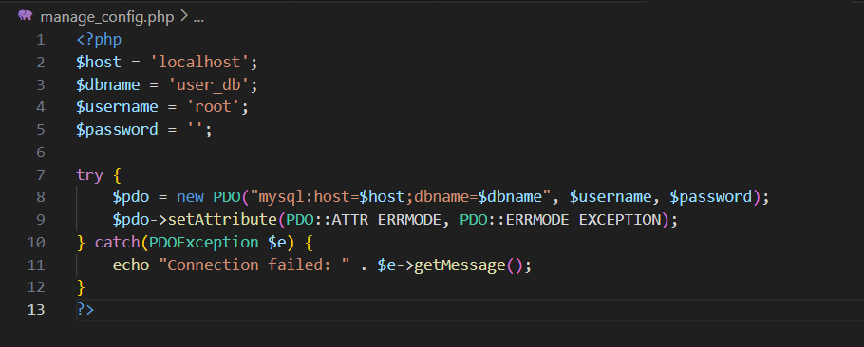

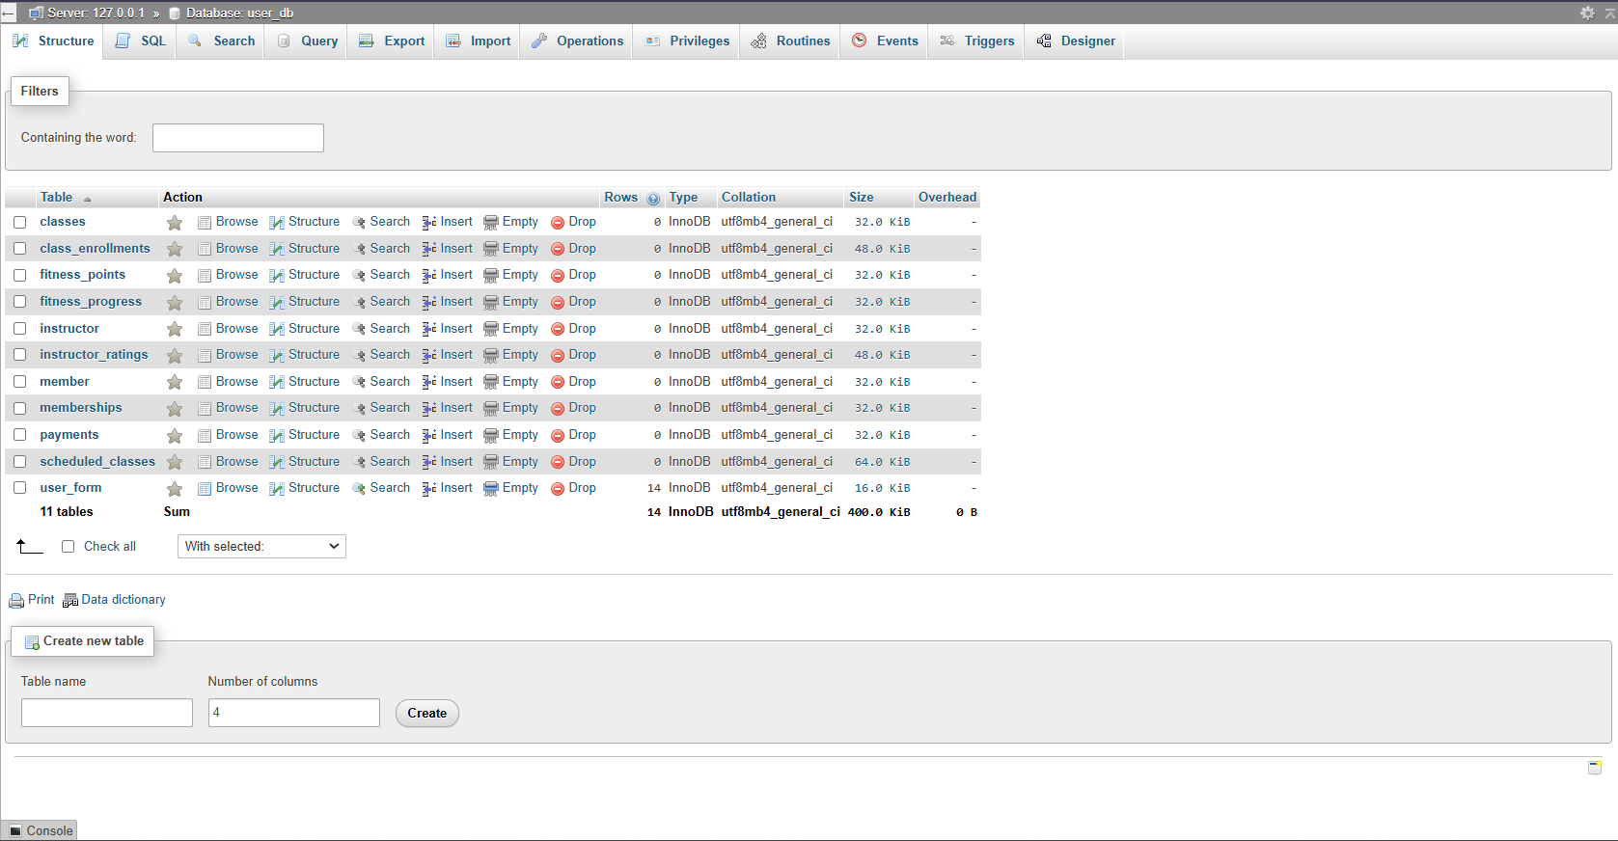

## Payment Process

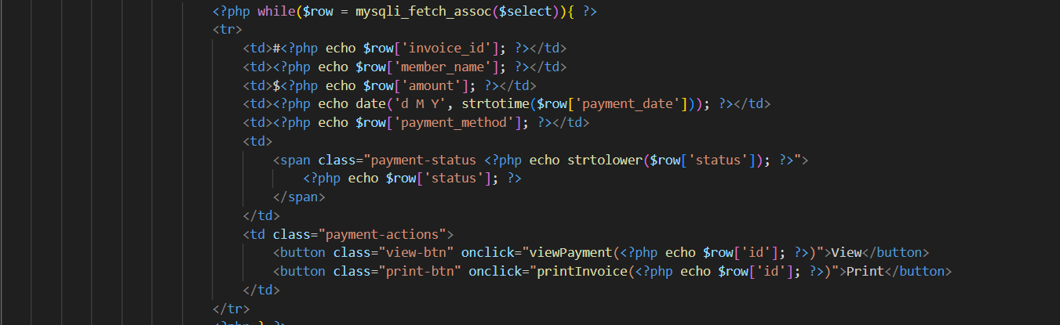

Sql Query

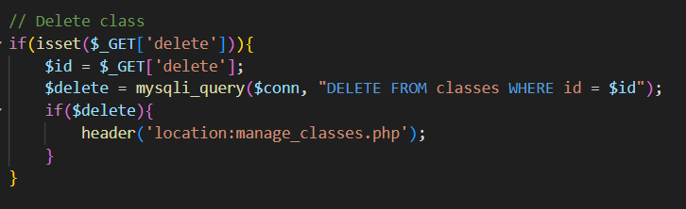

## Using Session

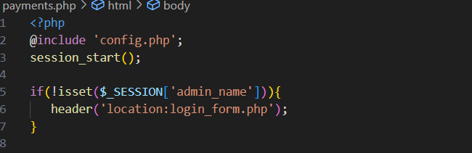

## Conclusion of Back-end Development

* important of Security : For the security considerations and to prevent the loss of the user data input validation, prepared statements and sessions are required.
* Error Handling: Recovery and enhancing the confidence of users on the program requires proper error control and clear messages.
* Data management efficiency: The two most important factors that can be improved through the optimization of queries and effective design of the databases scale down the server load hence improving the responsiveness of the application.
* User-Centric Design: Some of the backend characteristics such as scheduling for the classes and customer inquiries were also eased by the user input hence was find suitable to implement.

# Task 04

## Testing the FitZone Web application

### Testing Overview

The goal of testing the Fit Zone Fitness Center website is to make sure that every feature works as it should, giving end users a seamless experience and averting any problems. Verifying user interactions, form submissions, security features, and appropriate answers for all user types—including consumers, gym management, and administrators—is part of this. Functional, usability, and performance testing will be our main priorities as we employ both automated and manual testing methodologies.

### Testing and evaluation of the system

#### Objectives:

* Verify essential features including admin administration, appointment scheduling, class booking, user registration, and login.
* Find and address usability problems to guarantee a simple and easy-to-use interface.
* Verify that the program satisfies security standards, particularly those pertaining to user data protection.

### Scope:

* Functional Testing: Approve all the user operations and server side procedures.
* Usability Testing: How easy is it to navigate through thewebs ite layout and its design?
* Performance Testing: Likewise, there should be evaluation of response times to such requests, particularly the most common ones.
* Compatibility Testing: Cross browser and cross resolution testing should also be done.
* Security Testing: Ensure that the authentication, the authorization process and data protection procedures are effective.

## Test Cases

Tast case 1: Function of the register button

|  |  |
| --- | --- |
| Test Case ID | TC - 01 |
| Test Scenario | Function of the register button |
| Test Steps | * Open the home page * Click The Register button |
| Expected Result | Go to the register page |
| Actual Result | As expected |
| Pass/Fail | pass |





Tast case 2: Function of the Join us button

|  |  |
| --- | --- |
| Test Case ID | TC - 02 |
| Test Scenario | Function of the Join us button |
| Test Steps | * Go to the home page. * Click the Join us button. |
| Expected Result | Go to the login page |
| Actual Result | As expected |
| Pass/Fail | Pass |





Tast case 3: Register a new member

|  |  |
| --- | --- |
| Test Case ID | TC - 03 |
| Test Scenario | Register a new member |
| Test Steps | • Go to the registration page.  • Enter valid information for all fields (name, email, password and confirm password)  • Click the "Register" button. |
| Expected Result | data is saved in the database.& go to the Login page |
| Actual Result | As exepected |
| Pass/Fail | Pass |

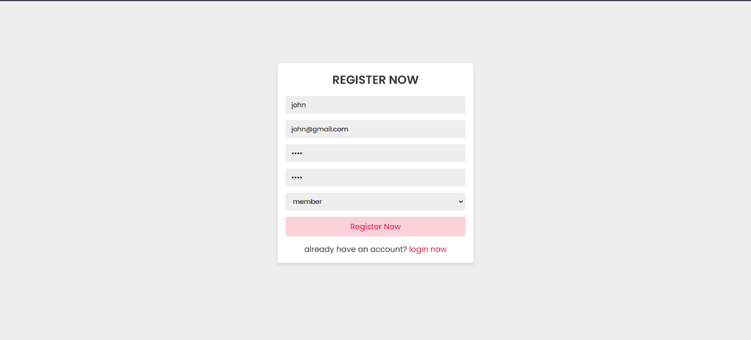

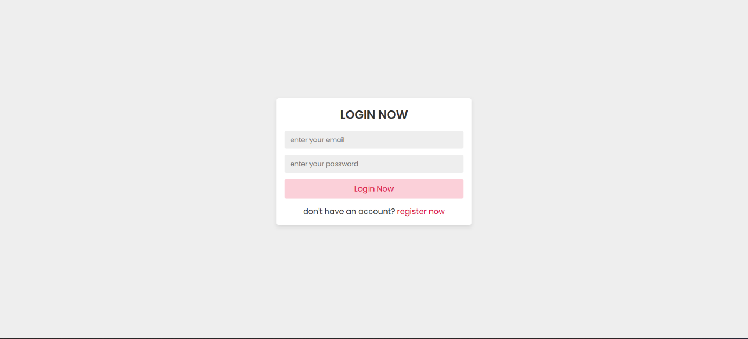

Tast case 4: Register a new instructor

|  |  |
| --- | --- |
| Test Case ID | TC - 04 |
| Test Scenario | Register a new instructor |
| Test Steps | • Go to the registration page.  • Enter valid information for all fields (name, email, password and confirm password)  • Click the "Register" button. |
| Expected Result | data is saved in the database.& go to the Login page |
| Actual Result | As exepected |
| Pass/Fail | Pass |

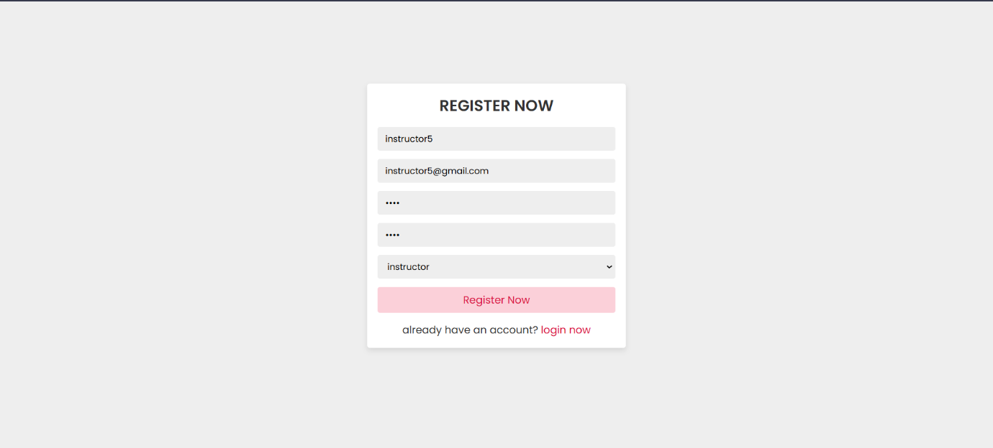



Tast case 5: instructor login using wrong password or user name

|  |  |
| --- | --- |
| Test Case ID | TC - 05 |
| Test Scenario | instructor login using wrong password or user name |
| Test Steps | Using incorrect password or user name |
| Expected Result | Notification comes as incorrect email or password |
| Actual Result | As expected |
| Pass/Fail | Pass |

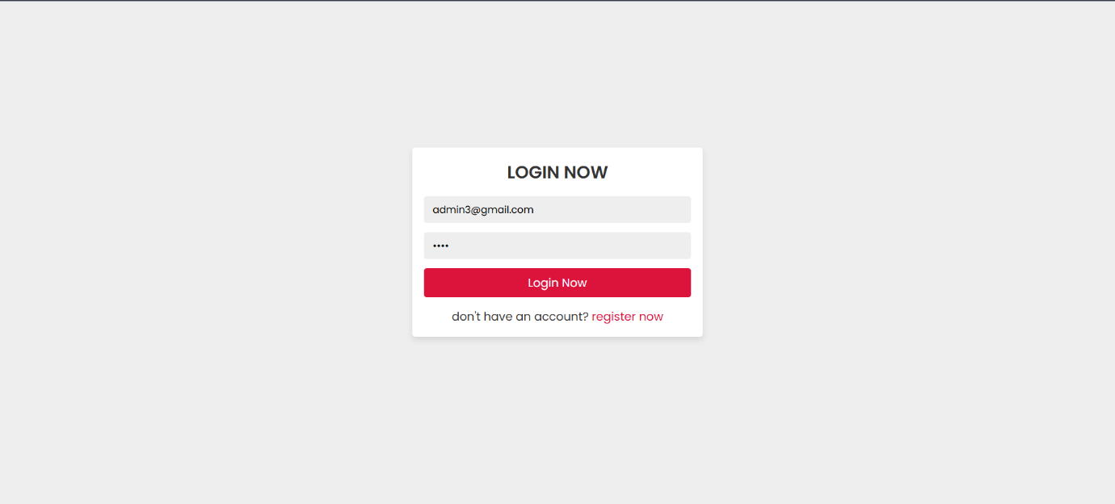

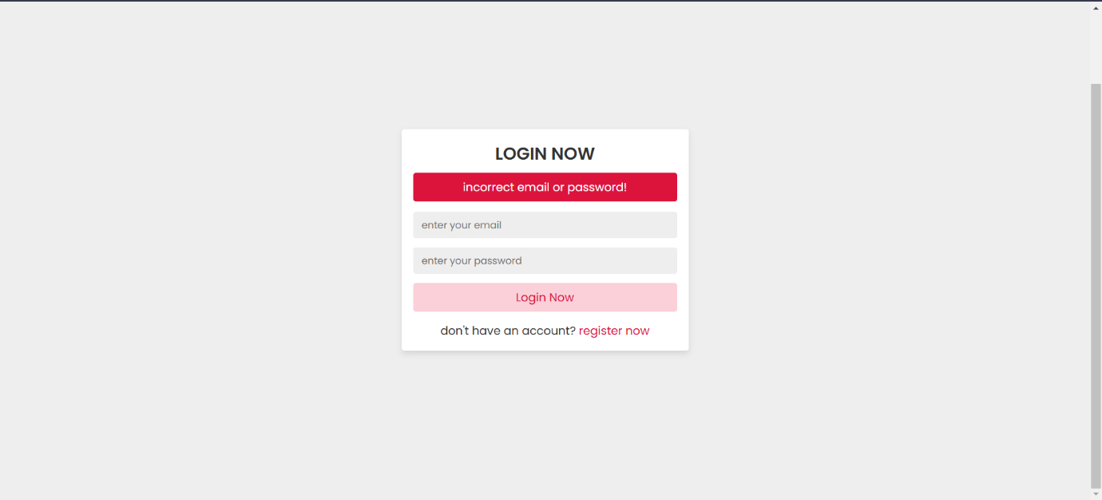

Tast case 6: instructor login

|  |  |
| --- | --- |
| Test Case ID | TC - 06 |
| Test Scenario | instructor login |
| Test Steps | • Navigate to the login page.  • Enter information for all fields with mismatching confirm password  • Click the "Login now" button. |
| Expected Result | Go to the instructor dashboard |
| Actual Result | As expected |
| Pass/Fail | Pass |



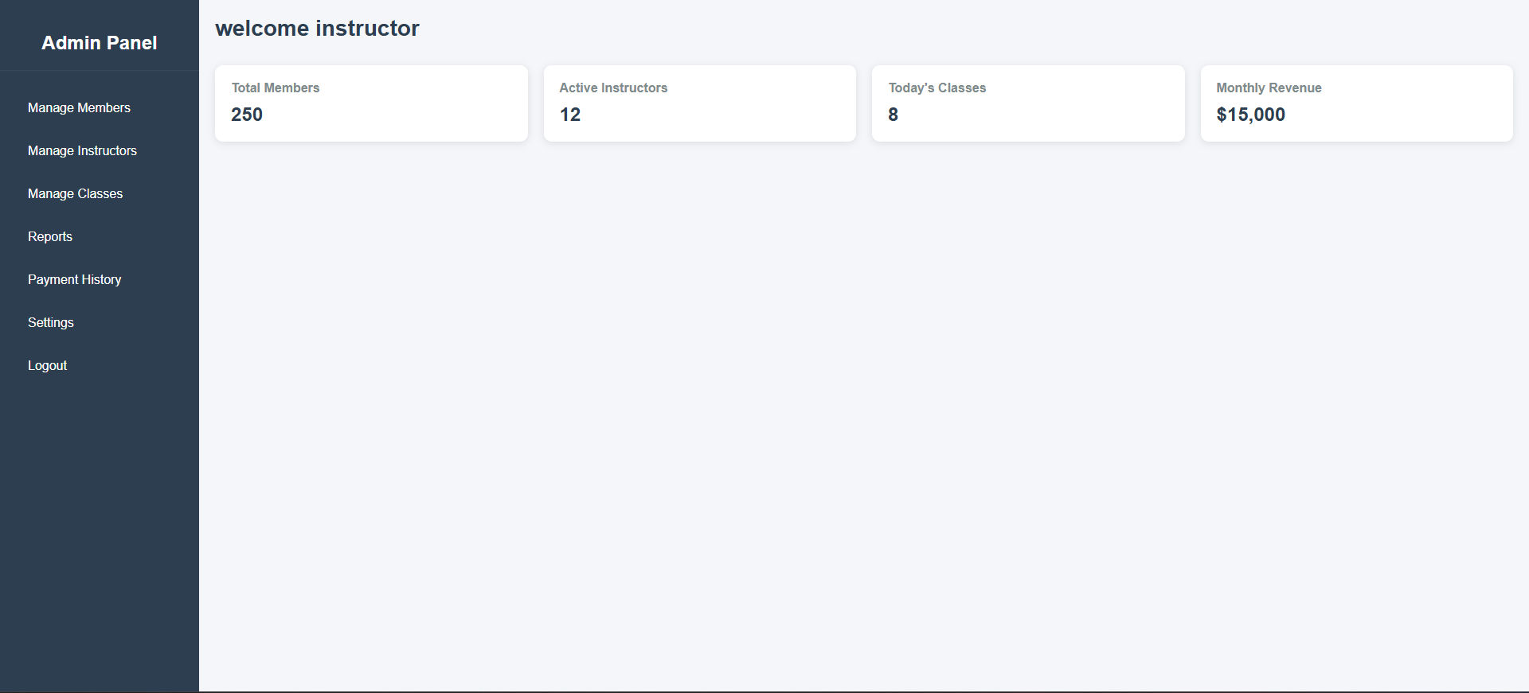

Tast case 7: Admin login

|  |  |
| --- | --- |
| Test Case ID | TC - 07 |
| Test Scenario | Admin login |
| Test Steps | • Navigate to the login page.  • Enter information for all fields with mismatching confirm password  • Click the "Login now" button. |
| Expected Result | Go to the admin dashboard |
| Actual Result | As expected |
| Pass/Fail | Pass |

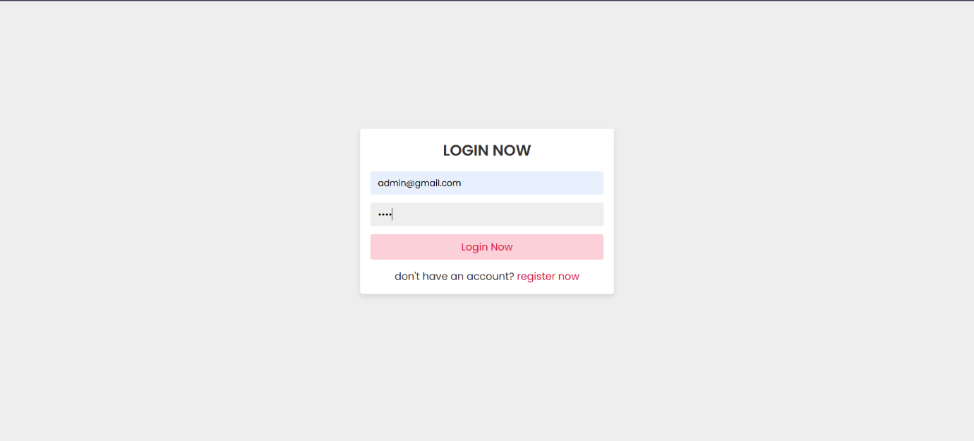

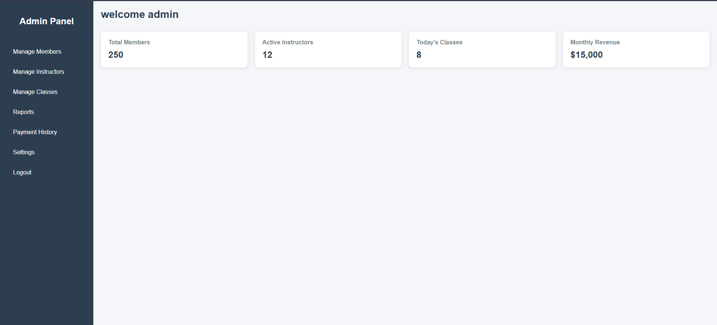

Tast case 8: Member login

|  |  |
| --- | --- |
| Test Case ID | TC - 08 |
| Test Scenario | Member login |
| Test Steps | • Navigate to the registration page.  • Enter information for all fields with mismatching confirm password  • Click the "Login now" button. |
| Expected Result | Go to the admin dashboard |
| Actual Result | As expected |
| Pass/Fail | Pass |

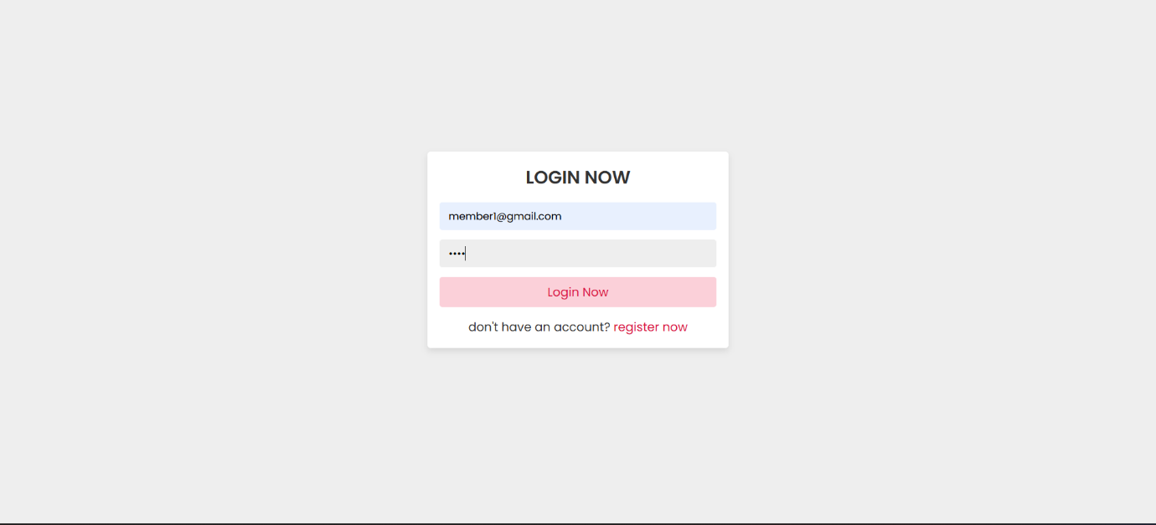

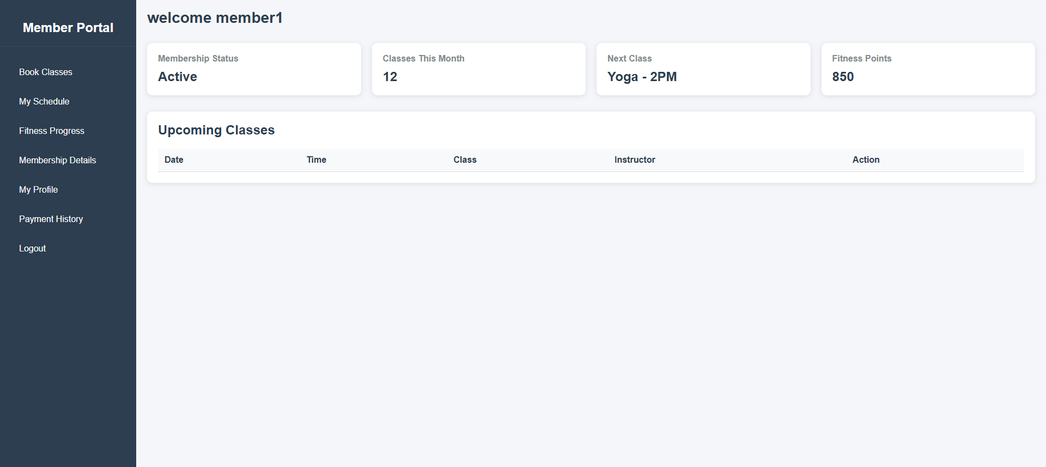

Tast case 9: adding a member by admin

|  |  |
| --- | --- |
| Test Case ID | TC - 09 |
| Test Scenario | adding a member by admin |
| Test Steps | * Go to the admin dashboard * Click add member button * Go to the register page * Fill the form * Click register button |
| Expected Result | Register a new member |
| Actual Result | As xpected |
| Pass/Fail | Pass |



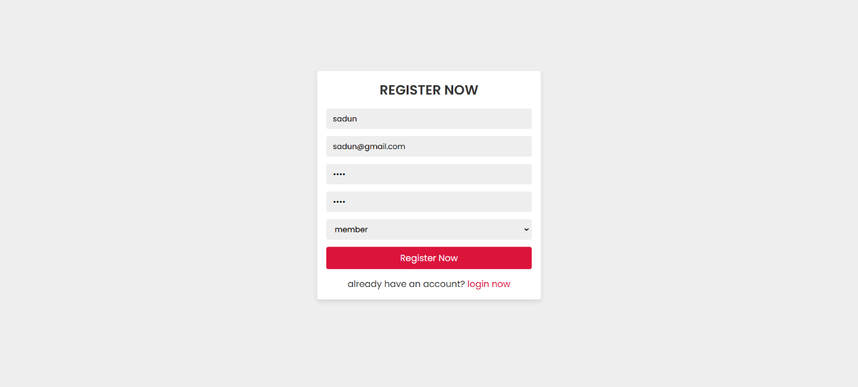



Tast case 9: adding a instructor by admin

|  |  |
| --- | --- |
| Test Case ID | TC - 09 |
| Test Scenario | adding a instructor by admin |
| Test Steps | * Go to the admin dashboard * Click add member button * Go to the register page * Fill the form * Click register button |
| Expected Result | Register a new instructor |
| Actual Result | As xpected |
| Pass/Fail | Pass |



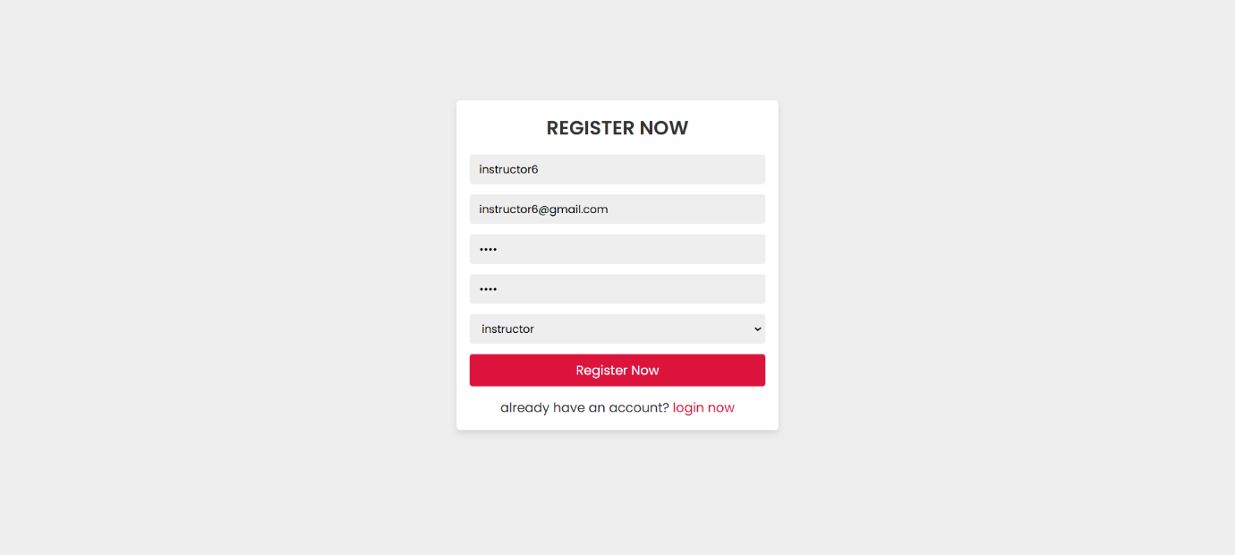



## Feedback Evaluation and Future Recommendations

## Feedback Evaluation

* Ease of Use: The interactions of the users were quite friendly with the application; good instructions were followed, and navigation was friendly as well.
* Performance: Organization’s web page states that it was capable of handling up to lot of concurrent users with insignificant response time.
* Functionality: Essential functionalities that are booking of appointments, registration and management of profiles were integral.
* Compatibility: The site was perfectly build to work on most of the leading browsers and on most of the mobile platforms.
* Security: The authentication system was strong and this minimized cases of intruder attacks on the system.

## Future Recommendations

* Implement Advanced Analytics: As it provides service for users and appointments, the analytics can be implemented to records the interactions and the trends of appointment to enhance the services.
* Add User Notifications: Allow Customers to receive notifications on their emails or phone for appointments, class reminders and announcements.
* Conduct Load Testing: It’s good to conduct load testing as the user base increases in order to ensure the application is still reliable.

# Summary

In order to improve user engagement and streamline fitness center administration, FitZone Fitness Center developed a dynamic website, which is detailed in this paper. The user interface design was guided by a wireframe layout and sitemap, which made sure the website was both aesthetically pleasing and simple to use.

While the backend was put in place to handle user accounts, appointments, classes, and other features, the frontend of the website was created utilizing contemporary design approaches to make it visually appealing. To ensure the best possible user experience, extensive testing was done to confirm the site's responsiveness on mobile devices and compatibility across various browsers.

# References

globalfitnesscenter, 2024. *globalfitnesscenter.* [Online].

https://karve.club/, 2024. *https://karve.club/.* [Online]   
Available at: https://karve.club/  
[Accessed 15 November 2024].

lifetimefitness, 2024. *lifetimefitness.* [Online]   
Available at: https://www.lifetimefitness.lk/  
[Accessed 15 November 2024].

powerworldgyms, 2024. *powerworldgyms.* [Online]   
Available at: https://www.powerworldgyms.com/  
[Accessed 15 November 2024].